DIAGRAMS TO CREATE :

1. Solar energy angles -

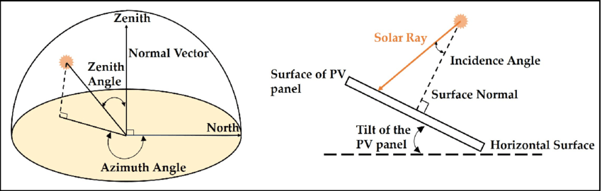

1. Taxonomy - <https://ars.els-cdn.com/content/image/1-s2.0-S2666546821000148-gr2.jpg>
2. Solar radiation in Earth’s atmosphere

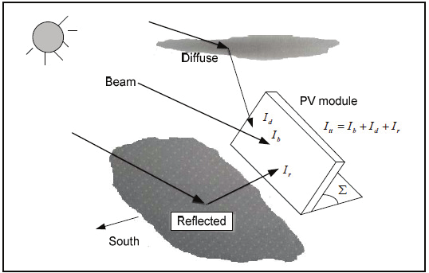

1. GHI - <https://slideplayer.com/slide/10383902/35/images/28/GHI%2C+DNI+and+DHI+Relationship.jpg>
2. 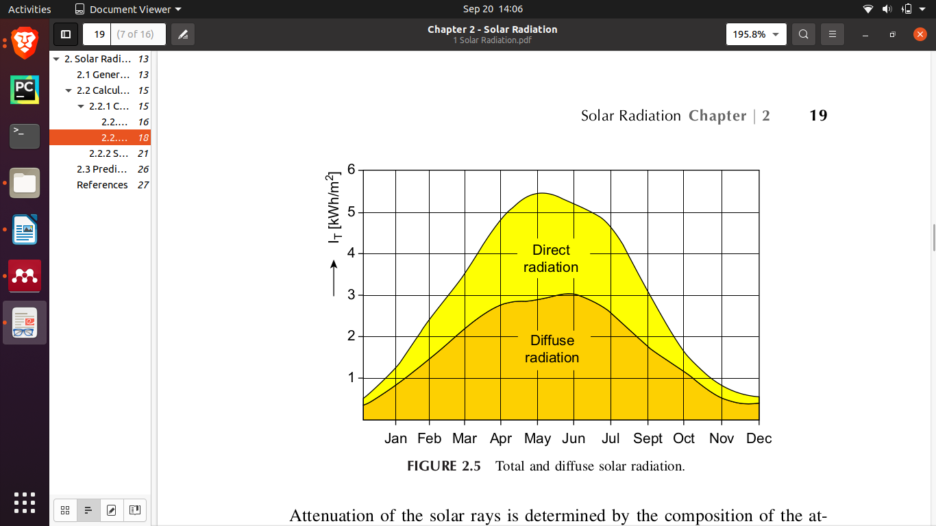

FLOWCHART TO CREATE

Meshva Papers :

1. 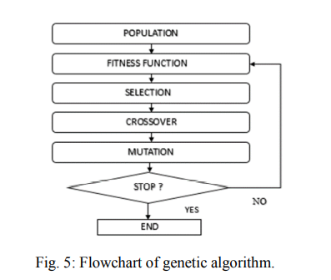

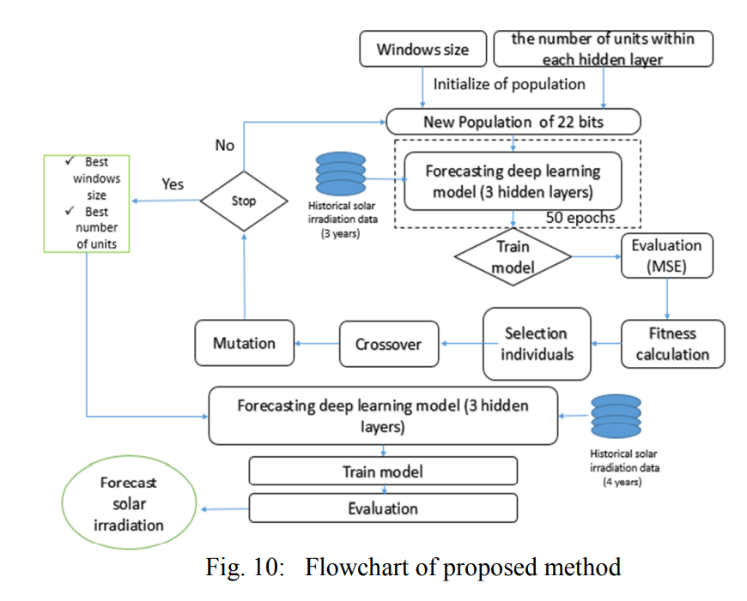

1. 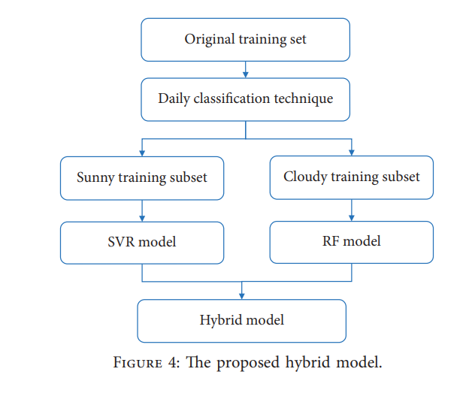

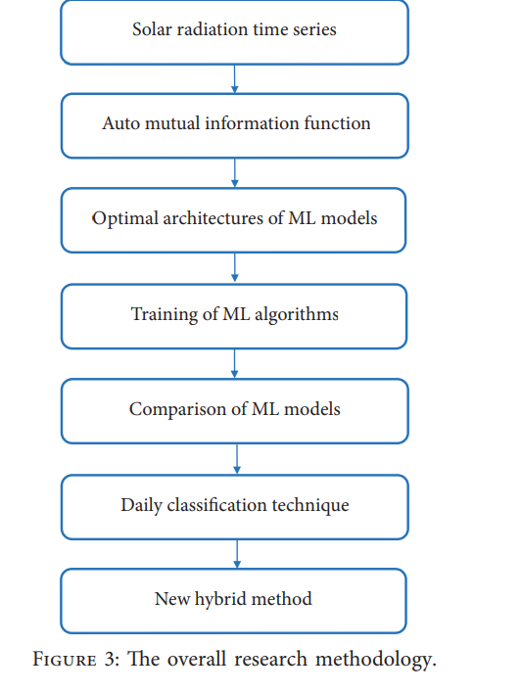

1. 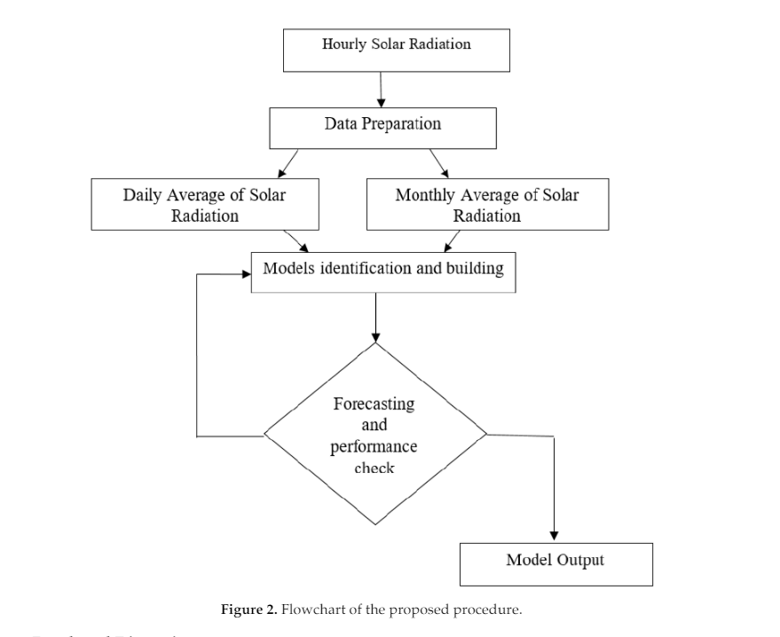
2. 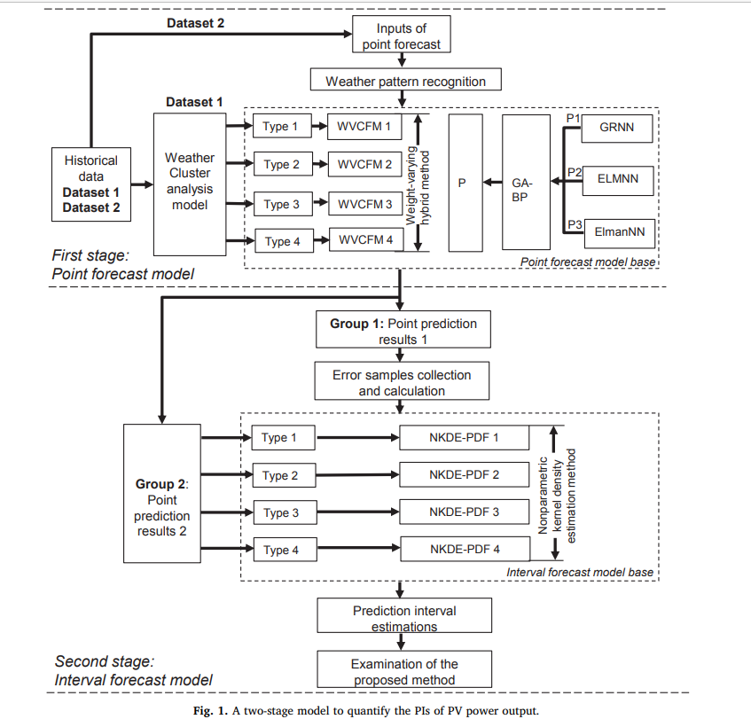
3. 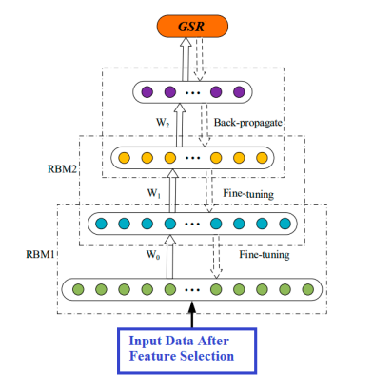
4. --NA--
5. 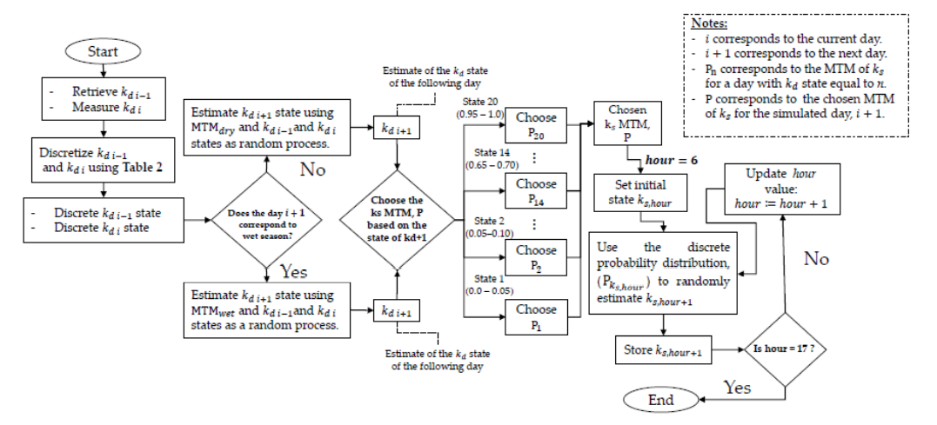

Saumya’s Paper Flowchart :

1. 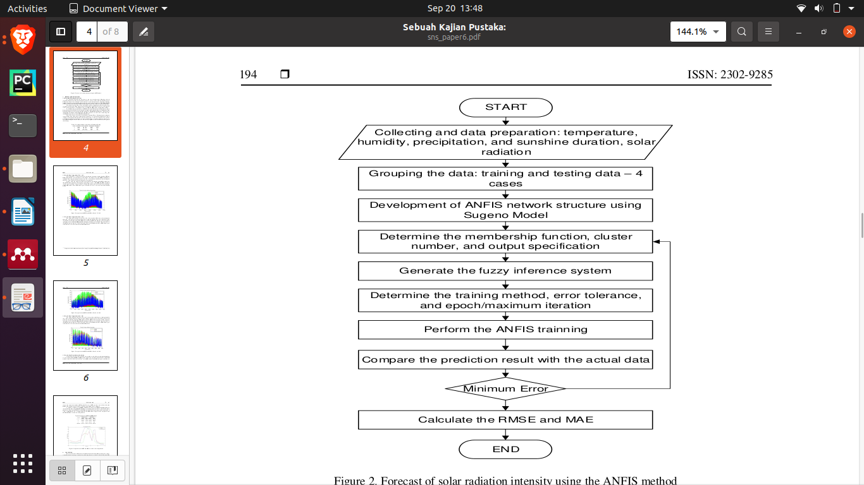

ANFIS modelling / methodology

1. 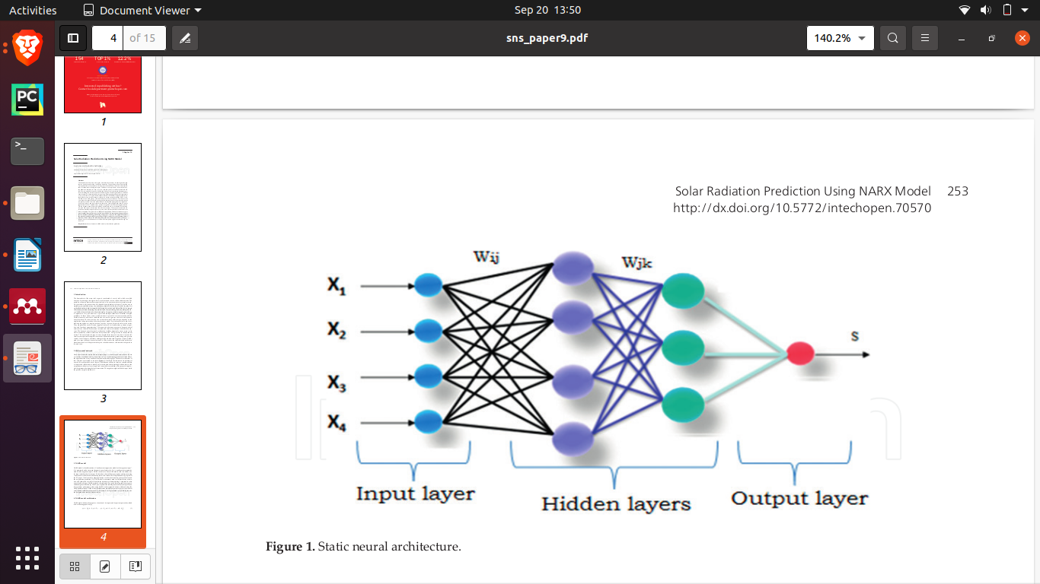

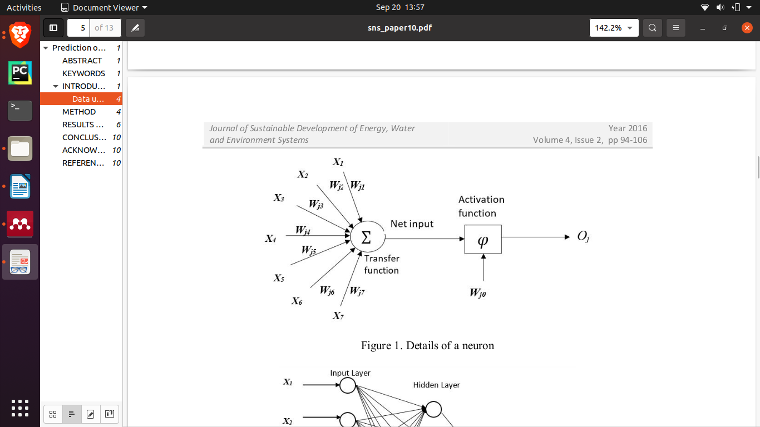

ANN Architecture

1. NARX Neural Architecture

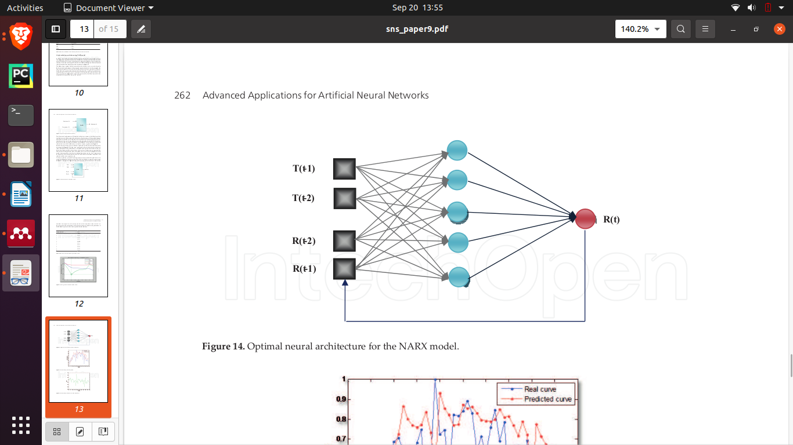

Formulas

| MAPE evaluation | [link 1](https://www.researchgate.net/profile/Chao-Hung-Wang-3/publication/27219891/figure/tbl1/AS:394224022376454@1471001739320/MAPE-CRITERIA-FOR-MODEL-EVALUATION.png) | [link 2](https://i.imgur.com/YYMpqUY.jpg) |
| --- | --- | --- |
| MSE, MAE, RMSE, R2 evaluation | [link 1](https://4.bp.blogspot.com/-wG7IbjTfE6k/XGUvqm7TCVI/AAAAAAAAAZU/vpH1kuKTIooKTcVlnm1EVRCXLVZM9cPNgCLcBGAs/s1600/formula-MAE-MSE-RMSE-RSquared.JPG) | [link 2](https://miro.medium.com/max/611/1*jopCO2kMEI84s6fiGKdXqg.png) |
| Error Abbreviations | [link](https://www.researchgate.net/publication/327029380/figure/tbl3/AS:668965957279753@1536505321675/Abbreviations-for-statistical-measures-for-the-validation-of-machine-learning.png) |  |
| Correlation Index | [link](https://businessjargons.com/wp-content/uploads/2016/04/Karl-Pearson-final.jpg) |  |
| nRMSE | [link](http://link/) |  |
| Kurtosis | [link 1](https://mvpprograms.com/help/images/KurtosisPict.jpg) | [link 2](https://miro.medium.com/max/1400/1*3VoJeU1_HR47ORCjt9oRJA.png) |
| Jacques-bera test | [link](https://digensia.files.wordpress.com/2012/05/jb4.png) |  |
| Phillips-Perron Test | [link 1](https://en.wikipedia.org/wiki/Phillips%E2%80%93Perron_test) |  |

**GHI = DNI*cosθ + DHI**

We also need something for gti

**I = S cosZ** ; i= solar insolence, Z=zenith angle, S= solar constant = 1000W/m^2

For one flowchart showcasing all methodologies available to us for each of the three classes of algorithms

Solar Radiation Prediction

* Neural Network based models
  + - ANN, ANFIS, MLP, GRNN, ELMNN, HELmanNN, WVC FM, DBN,RBFNN,MLFNN
* Statistical / Heuristics / Probabilistic Models
  + ARMA, TDNN, Random Forest, Decision Tree, XGBR, Node2Vec, Markov chain model, Genetic algorithm, SVR
* Time-Series Models
  + GLSSVM , PCA, WD, WDPCA , PCAWD, Seasonal ARIMA, NARX, ARMA, ARMAP

